NORTH & MID WALES ASSOCIATION OF LOCAL COUNCILS

Report no 9a
North Wales Coast
Chester to Shrewsbury
Cambrian main
and Wolverhampton to Shrewsbury
Report

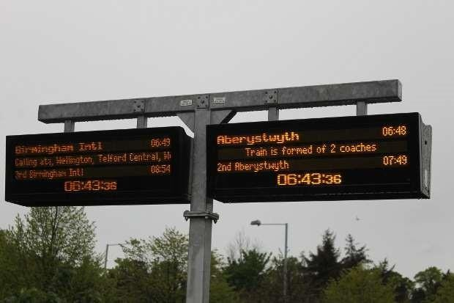

Cllr I Hodge Cllr N Davies
Cllr Helen Roberts Cllr Vivienne Blondek
Cllr Trevor Roberts
Robert Robinson MBE(Secretary)

12th September 2025

For more information or interviews please contact the secretary. 07767 267830 or email supercommuter@mailcom
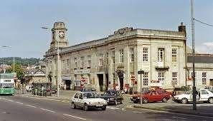

FOREWORD.

The railways are represented by liaison committees and user groups covering most if not all of the lines in the UK. There was a strong liaison committee in place for the Cambrian Lines and North coast line with a less strong one for the Shrewsbury-Chester line.

With the introduction of new rail timetables supported by new trains there is to be extensive change over the coming few years. Particularly with changes in travel patterns and rail usage.

The Cambrian Lines has now combined with the North Wales Coast lines to form a single liaison committee taking an overview of the network between Mid and North Wales.

This report sets out the findings of surveys carried out in July and August 2025 and covers:

- Train usage
- Travel patterns
- Customer service
- Trains and timetabling
v) Comparisons between the current and proposed services

The main report will cover the results and conclusions from the surveys with evidence. There will also be a more detailed report on each survey conducted attached to the main report.

There will be another survey completed the spring and summer months 2026. When the new 197 stock is introduced fully another set of surveys will be completed to compare the results .

Finally the report offers an objective view with recommendations.

We will share the findings of this report a copy will be issued to Transport for Wales, Welsh Government, Avanti Trains.

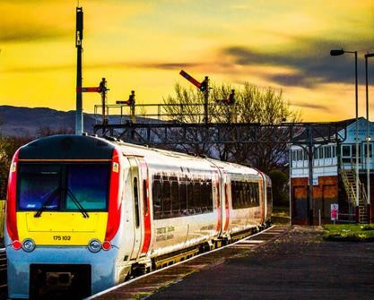

CONTENTS

Forward page 2
- The Association page 4
- History and introduction page 5
- Aims & objectives of the report page 7
- Survey method page 8
- North Wales Coast line page 9
- Llandudno Junc - Wolverhampton page 13
- Cambrian main line page 15
- Recommendations page 19
A. Survey instructions
B. Survey charts
C. Notes on the days surveyed
D. Suggested top priorities.

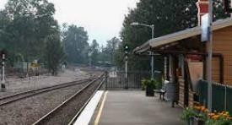

1. The North & Mid Wales Association of Local Councils

The Association was originally formed over 45 years to represent the residents in North Wales. In the last 25 years this has expanded to include Mid Wales.

The current membership comprises approx 25 Town or Community Councils covering a whole range of communities who are full members. In addition there are 15 associate members (with particular transport interests)

The Association meets every three months with all members present and every three months an executive meeting is held. The day to day running of the Association is vested in the secretary in consultation with the Chair and Vice Chairs.

In more recent times the Association has set up a particular interest section with regard to transport.

There are two transport committees within the Association which are:

The North Wales Cost Transport Group (Chair Cllr Ian Hodge)

The Cambrian Lines Group (Chair Cllr Trevor Roberts)
(Shrewsbury-Aberystwyth with the Cambrian Coast)

These groups meet twice a year and in addition meet twice a year together.

Invited to the meetings are also our local MP’s, Senedd Members, Transport for Wales, Avanti, Network Rail and the Cambrian Partnership.

Since 2103 the Cambrian Lines have conducted many surveys and where possible this report compares the current survey to these as appropriate.

The survey has been conducted and put together by volunteers with the support of Transport for Wales.

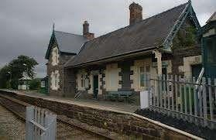

2. Introduction and history

2.1 Introduction
The Cambrian Lines have seen many changes in recent years from the introduction of the new signalling system to the introduction of an improved timetable introduced in May 2015. This is the second of the combined Cambrian Lines, Shrewsbury-Chester and North Wales Coast lines which have been combined into a full survey joint report.

2.2 Brief history
The Welsh rail services have been covered for many years by a separate franchise along with further trains from Paddington – South Wales/Hereford and from Euston - Holyhead along the North Coast.

Wales and Borders held the franchise in the earl 2000’s followed by Arriva Trains Wales until a few years ago when Transport for Wales was formed being Welsh Government owned.

Transport for Wales has had a difficult start with many trains ageing, not enough stock being available along with the effects of the Covid epidemic.

Unlike the Arriva Trains franchise (based upon no growth) when the new franchise were giving their presentations part of the ‘sales pitch’ by all of them was that Welsh Government was looking to ‘future proof’ the rail services with increased capacity. This report will address some of these issues within its content. This to date has not been evident in some areas. If the projected passenger numbers had taken place our trains today or as designed into the near future would not cope. The current rail stock is leased until 2033 and plans for what happens after that needs to be considered sooner rather than later.

2.3 Current rail services
The current rail services have the following features:

- The Cambrian Lines has more trains so that there is an hourly service in peak periods.
- Many trains are short (i.e. two cars) and are extensively overcrowded.
- Lack of rolling stock – new 197 stock delayed.

Continued….

- Investment into the infrastructure has been extensive.
- Plans to open some more stations at Deeside, Wrexham and Holywell have been announced and a new station has been completed at Bow Street.
- Some station improvements have been completed and others about to be completed
(i.e. Newtown Lifts)
- Progress in many areas is slow and cumbersome.

2.4 Proposed rail services
The proposed rail services have the following features:

- New and faster trains.
- The new trains are good for commuter traffic but not long distance journeys with many issues (noted elsewhere in the report).
- Improved timetables in many areas but with some loss of capacity identified.
- Metro systems are being introduced.
v) Number of units due to arrive are not enough to meet the growing public demand as demonstrated by this report.

2.5 Working together
The relationship between the rail operating companies and the liaison groups continues to be good with worthwhile exchanges of views.
However, the liaison groups would like to see more notice taken of the real issues. It is too common to hear later the statement ‘we have learned from it’.

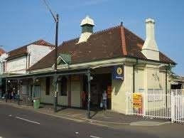

3. Aims and objectives of this report
The aims and objectives of this report are:
- To compare customer satisfaction regarding rail travel with surveys carried out over past years to ascertain their views and to assess how well the railway companies are doing.
- To take specific days and assess performance with regard to time keeping, cancellations and other timetable matters which affect the public on the lines surveyed.
- To assess various aspects of the experience of travelling by train and to observe matters of importance.
- To assess passenger numbers on the lines surveyed and to compare same with the past and to assess what effect such numbers will have in relation to the new 197 class trains due to coming effect.
- To make recommendations as to what might be considered due to the results of this report.
- To make the survey available to Westminster and Cardiff governments, rail operators, councillors and the general public through publication of the final report.

The surveys the subject of this report were carried out as follows:

Tuesday 19th August | Chester-Shrewsbury Lines
Wednesday 13th August | Cambrian Coast Line
Thursday 31st July | North Wales Coast Line

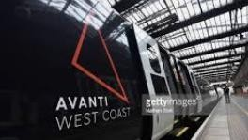

4. Survey method

4.1 Method statement
The survey method adopted is manual with people conducting the surveys on the trains and gathering information during the day of the surveys.
The individual trains times on the day were measured by updates issued by the rail companies.

4.2 Methods used
The survey was carried out as follows:

- 3 days on board train services between:
Shrewsbury and Aberystwyth.
Chester and Shrewsbury
Chester and Llandudno Junction
Shrewsbury and Wolverhampton

- A meeting of the Association to gather local council views.

The surveyors did not express views but gathered information. The results of the surveys are based upon evidence gained.

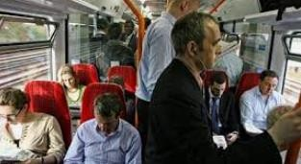

5. North Wales Coast

5.1 Date of survey
The survey was completed by Cllr Ian Hodge with Cllr Norma Davies on Thursday 31st July 2025 and by Cllr Vivienne Blondek with Cllr Helen Roberts on Tuesday 19th August 2025.

5.2 Overall results of survey

TRAVEL PATTERNS - REASON FOR JOURNEY

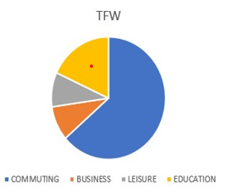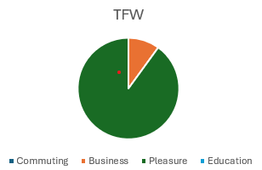
2024 2025

Note: Business travel has remained constant, leisure travel has increased with fewer using the trains for commuting and education.
The reasons for the change appear to be cost, working from home and inability to work on the train due to lack of space.

TRAVEL PATTERNS - HOW OFTEN PEOPLE TRAVEL

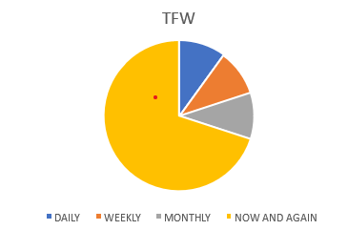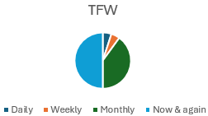

2024 2025

NOTE – from enquiries talking to passengers the drop is regular train use is due to reliability and overcrowding (Covid is still an issue for many). The number of occasional travellers is now the majority with monthly use second and mostly for leisure use. This is a similar result as in 2024 compared with 2025.

TRAIN JOURNEYS
During the days (taking all trains through this route) the following reliability pattern emerged:

TRAIN PERFORMANCE
Train services on the day of the survey were good all running to time or within a few minutes.
No cancellations were experienced during the survey.

TRAIN CAPACITY
The numbers of people on the trains at each station along the survey routes were counted and recorded.
Copies of these are attached on page

When assessing the loadings they are measured against the actual train and against the alternative trains that appear at various intervals.

The charts show that a 3 or 4 car unit can cope with passenger numbers along the whole of its route, a two car unit cannot.

The reference to the colours in the charts are based upon the following passenger loadings:

NOTE – KEY to charts
Black- dangerous levels over 100% seating taken
Red-overcrowded Over 80% seating taken
Very busy Over 70% seating taken
Busy Over 60% seating taken
Space available Under 60% seating taken

GENERAL OBSERVATIONS
From the observations made by the surveyors during their journey the following were of note:
- Toilets were clean and working but customers still not totally impressed.
- Much lower train passenger numbers for this time of year.
- Numbers still show the need for three or four carriage trains to avoid overcrowding.
- Security guards at Prestatyn to stop people boarding the overcrowded trains have reduced probably due to the increase in Avanti reliability.
- With so many people close to the doors the danger of people falling out is greater and with the gaps and height of the stop off is a hazard. On commuter trains people are more aware of this, however, on long distance journeys people forget.
- Strengthening trains on Saturdays on the North Coast would be welcomed.
- Better bus links with later trains would be welcomed.
- Buttons on lifts could do with better identification.

FULL DETAILS OF THE CUSTOMER SURVEY RESULTS (North Coast)
Copies of survey forms and date are retained by the Association but are available for inspection by arrangement.
The executive summary sets out the results of the survey taking into account all the lines covered.
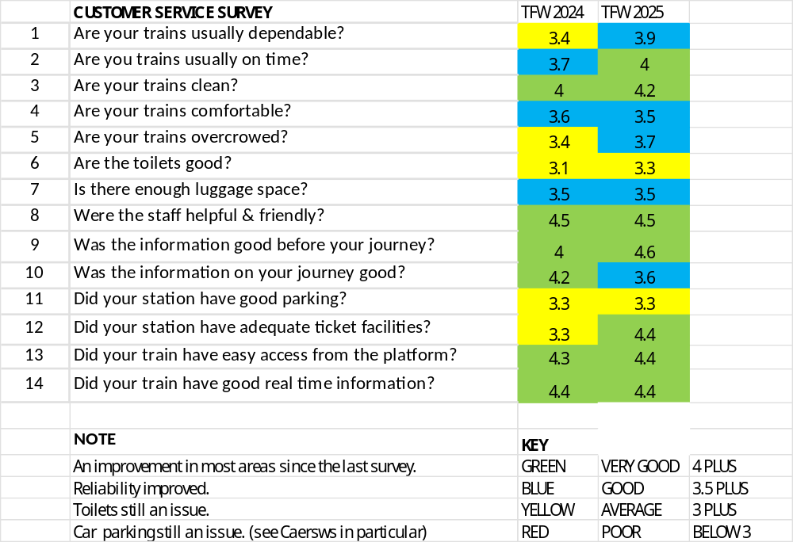



6. Llandudno Junction to Wolverhampton

6.1 Date of survey
The survey was completed by Cllr Vivienne Blondek and Cllr Helen Roberst on Thursday 19th August 2025.

6.2 Overall results of survey

TRAIN TIMES
The trains during the day of this survey were poor. Cancellations and delays meant that all the survey routes that were planned were not covered. See notes of Cllr Helen Roberts at the end of this report.

TRAIN CAPACITY
The trains were lightly loaded with only a few points where overcrowding was observed.
Details of the survey results are attached.

GENERAL OBSERVATIONS
From the observations made by the surveyors during their journey the following were of note:
- Lower passenger numbers than last year at this time of year.
- Missing connections with ferry at Holyhead often an issue.
- Various comments regarding passenger care in attached daily report.
- A replacement train (due to operational issues) appeared to have utilised older rolling stock in substandard condition. The train presented multiple lack of cleanliness and maintenance concerns:
• General uncleanliness throughout the formation

Continued…..
• One toilet completely out of service
• Remaining toilets in wet and dirty condition
• Poor overall maintenance standards
- Limited Wi-Fi at Shrewsbury station.

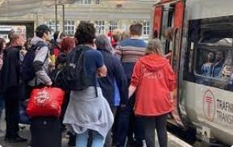

7. Cambrian Main Line (Shrewsbury to Aberystwyth)

7.1 Date of survey
The survey was completed by Cllr Trevor Roberts and Robert Robinson Wednesday 13th August 2023.

TRAIN TIMES
All the trains used during the survey were on time or close to being on time.

TRAIN CAPACITY
The numbers of people on the trains at each station along the survey route were counted and recorded. The results are shown on the chart attached at appendix .

The results showed a low level of rail usage on all the trains surveyed. In previous years the trains would have been at a level where there was standing room only. On this day there were many seats on each train.

The charts show an assessment of each train using the following basis:

GENERAL OBSERVATIONS
From the observations made by the surveyors during their journey the following were of note:

Continued…..
- Electronic signage ‘all over the place’. Lots of people confused at Shrewsbury. There are signs which show ‘on time’ at one moment and then goes straight to ‘delayed’ only to return to ‘on time’ again in a few minutes.
- The Wi-fi was intermittent, when it worked it was good.
- Station staff were very good and helpful.
- The passengers interviewed felt that train travel was generally more stressful than previously.
- Car parking a real issue at Caesws Station. Land has been secured so money should be made available to increase the car parking here.
- Limited Wi-Fi___33 at Shrewsbury station.

FULL DETAILS OF THE SURVEY RESULS
Copies of survey forms and date are retained by the Association but are available for inspection by arrangement.
The executive summary sets out the results of the survey taking into account all the lines covered.

12. Recommendations
The Association from the evidence of this and previous reports suggest the following recommendations:
- The current 158 stock should be retained on the Cambrian lines (ie Aberystwyth and Coast line to Birmingham) to allow enough of the new 197 stock whilst the situation is investigated fully and rectification put in place.
- Discussions start to take place with stakeholders on what happens when the trains on lease come up for renewal/review which we understand is 2033.
- All long distance class 197 trains should be 3 or 4 cars minimum. Two car units are not acceptable on all long distance timetabled services.
- The Holyhead and Aberystwyth service out of Birmingham is due to split at Shrewsbury with 2 cars going to each. We recommend that the four car train out of Birmingham goes through in total to Aberystwyth. A 4 car train for Holyhead should then start from Shrewsbury to meet this train.
The support for this proposal is shown in the survey results. (a two car unit on this service north of Shrewsbury is not acceptable and due to the number of passengers using this service would be unsafe and bordering on dangerous – maybe even illegal. Where there is a mitigation, it should be put in place – i.e. more capacity).
- More class 197 units should be fitted with ERTMS to give the flexibility required.
- There appears to be some issues with less able people and use of trains, this is worthy of some further investigation to ensure all is being done that is reasonable
- Discussions should commence with Welsh Government with regard to funding an extension to the car park at Caersws Station (land secured).
- Discussions and liaison between rail operators and ferry operators to improve connections between rail and ferry services at Holyhead.
- A further survey of numbers on trains should be carried out in spring and summer 2026.

Suggested priorities for both Cambrian and North Coast Lines are attached at appendix D.

APPENDIX A

NORTH & MID WALES ASSOCIATION OF LOCAL COUNCILS
CAMBRIAN LINES AND NORTH COAST RAIL SURVEYS
JULY AND AUGUST 2025

- Introduction
The purpose of this paper is to set out the survey plan for both the Cambrian Lines and North Coastline from Holyhead to Chester.
The plan is to inform and help us all to understand the changes over a long period of time and the customer view and perception of services over the same period.
The surveys will not be published other than to members of the Association/Transport for Wales/Welsh Government unless agreement to do so is in place.

- Previous surveys
The previous surveys were carried out in 2013, 2015 and 2017.
These surveys were pre-Transport for Wales and pre Covid.
The survey proposed (2023) will identify changes post Covid and the second one (2024) will show the differences between the current status and those following the introduction of the new trains.

- The survey
The survey would cover:

  - Number of people on the train at each station stop.
  - Assessment of space
  - Train timings
iv) Customer satisfaction survey

To give the full picture I enclose our report no 5 which covers one of the previous surveys and the surveys proposed will mirror those in this report.

The survey would be completed on the ground with volunteers. The persons carrying out the survey will be fully briefed before the day. They will visually record numbers on the train at the start of the journey and then estimate (as accurately as possible) the numbers getting on and off at each station.

They will between stations seek to gain a good sample of passenger’s views via a paper-based survey given out and collected back on the trains.

The results will be assessed and analysed to provide a direct comparison to the surveys carried out in 2013 – 2015 and 2017-2025

The questionnaire will be bi-lingual and will be similar to that contained in report no 5 attached to this paper.

- Dates and times
These will be carried out annually in the spring and summer.

- Final report
The final report will be issued to Transport for Wales for comment prior to any distribution to members of the Association and Rail Liaison Committees. The final report would be issued by the end of the year.

- What we need to complete the work
The Association will carry out the survey work using volunteers.
Transport for Wales is asked to issue free travel for those carrying out the surveys on the days of the activity.

APPENDIX B OTHER EVIDENCE (1)

NORTH WALES SURVEY NO 1

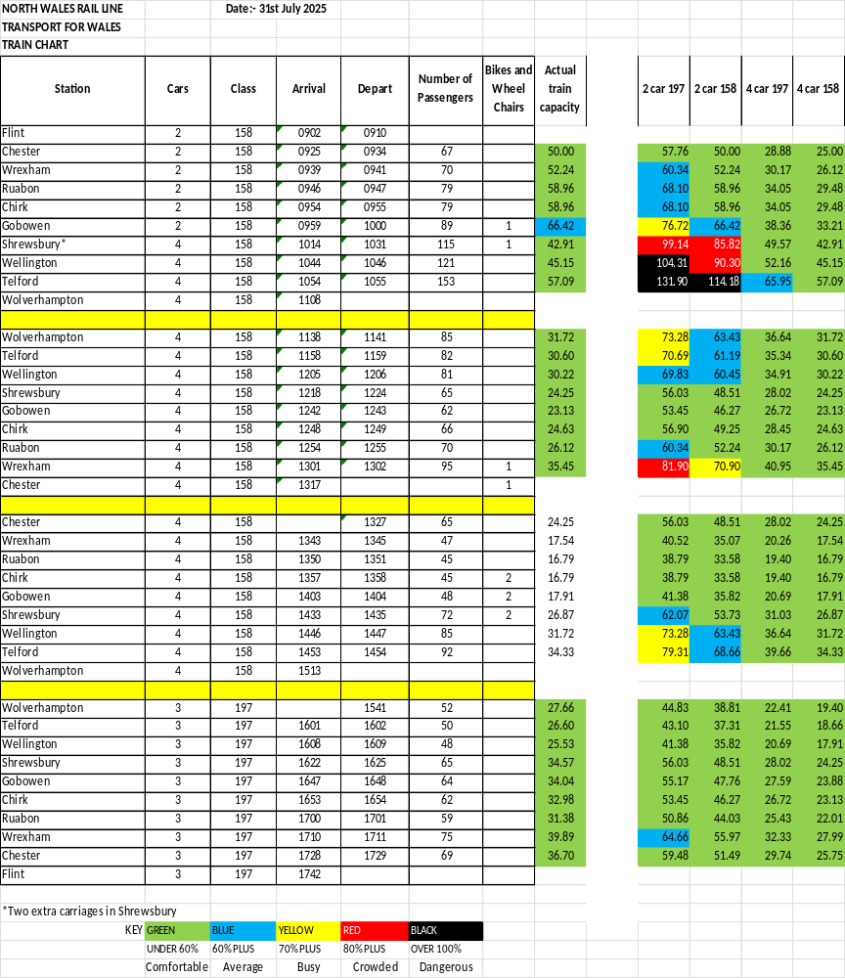

NORTH WALES SURVEY NO 2

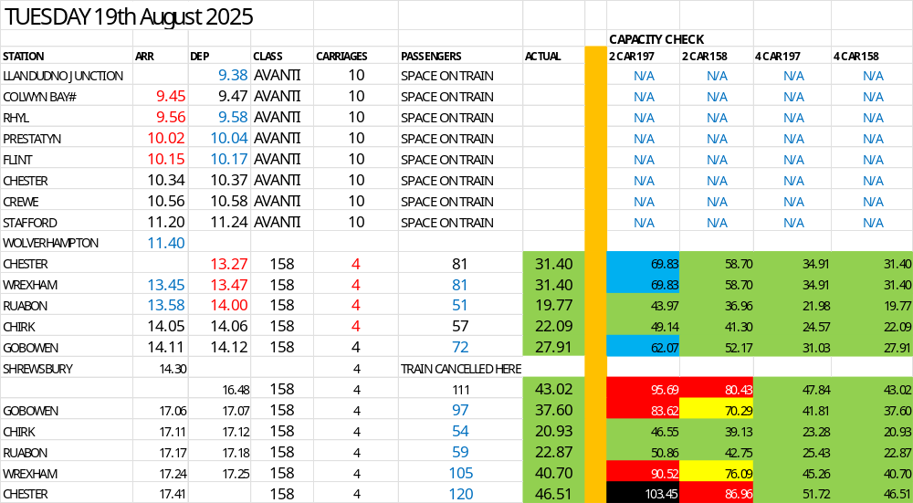

CAMBRIAN LINES SURVEY
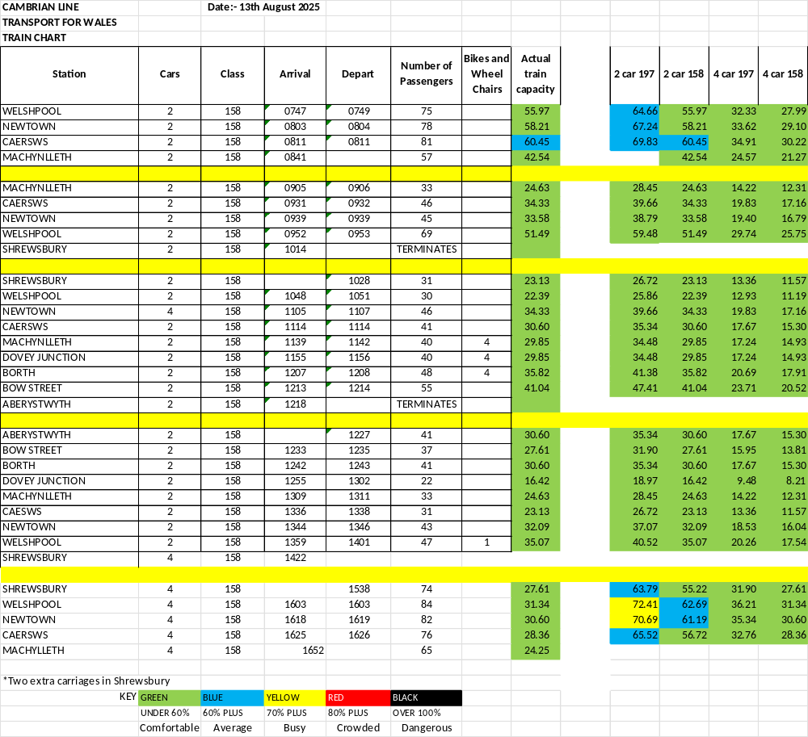

APPENDIX C

NOTES FROM NORTH WALES COAST SURVEY

(Helen Roberts notes – Tuesday 19th August)

I arrived on the platform at Llandudno Junction at 9.15 and went to the café to wait for Viv. The café is very good, clean and welcoming.

Planters on the station maintained by Incredible Edible. I visited the toilet, it was clean. Train was on time, Viv kept train notes.

The station has recently had a deep clean and paintwork refreshed. The café provided spent coffee grounds to passengers and Incredible Edible use these in the planters as fertiliser. I took every opportunity to chat to staff and passengers, all anonymous of course.

A regular traveller (employee) from Llandudno Junction to Llandudno observed and was quite annoyed by the connection timings here. Apparently there is frequently a 2 hour connection wait to get to Llandudno for people who have had to alight the Holyhead train to change, however at night there is only 10 minutes between two Llandudno connections (although one may be a straight through), leaving the second train empty. This person found this a terrible waste of money.

The same person also reported that at certain times, namely in the summer on a Friday and Monday there is one train that only has 2 carriages. Because of the holiday camps and visitors to Rhyl especially, once the train leaves Rhyl it is over full and the operator radios ahead to instruct the train to abandon the stops at Prestatyn and Flint which leaves legitimate passengers with tickets on the platforms.

I seem to remember that this is a problem we have heard before.

A gentleman passenger on the Chester/Shrewsbury train said he has met no end of passengers travelling to Holyhead who have missed ferries because of late trains (he has left his name and number on one of the surveys in case you would like to discuss further and possibly other issues).

This point was corroborated by a lady at Shrewsbury station who uses the ferry often to visit relatives, she has long learned that you cannot reliably catch the ferry train as it regularly gets in 7 minutes late and she has often missed the boat. She now gets a train two hours early to make sure.

We had a delay at Shrewsbury because a vehicle had hit a bridge near Telford and Viv and I had a coffee. All staff were very helpful and polite throughout the day.

Toilets at Shrewsbury clean and well kept.

Our shenanigans in Wolverhampton with missed connection because our train was late had actually caused us to be early at Shrewsbury and so we had longer than expected to lunch.

There was a terrific floral display at Chirk station which is always a cheery sight and seems to bring the railway alive.

Once we reached Chester on our return journey, we had been delayed and the train from Shrewsbury had been added to try and make up time lost. As a result from Chester it went straight to Llandudno Junction without stopping at Shotton, Flint, Prestatyn, Rhyl or Colwyn Bay.

It emptied apart from me and a smattering of others and indeed did make up the 25 minutes and I got off at Llandudno Junction. I have no idea what became of Viv or all those who had to wait for another train from Chester to get to the intervening stops.

It was a lovely day out with Viv who is constantly note taking. I only had one man who refused to fill in a survey and I suspect it was because I asked him in English and wasn’t quick enough to show him the Welsh side of the survey before he turned his head away. NB most young people don’t carry pens any more, this was one of my lightbulb moments. I made every effort to ask all manner of people to fill in questionnaires, from as varied backgrounds as I could manage.

The final train for me left Chester at 17.41 and arrived at Llandudno Junction at 18.22 after the delay it should have arrived in the Junction at 1836, so made good time in the end. It was a 4 carriage train.

VIVIENNE BLONDEK REPORT (19th August)

Date: 19th August 2025 Route: Llandudno Junction to Wolverhampton (return)
Surveyors: Helen Roberts and Vivienne Blondek

Journey Details
Outbound Journey: Llandudno Junction to Wolverhampton
Departure: 09:38 from Llandudno Junction Railway Station Route: Llandudno Junction → Stafford → Wolverhampton Rolling Stock: 10-carriage train

The reservation system was not functioning, causing substantial passenger disruption. Travellers were compelled to search extensively through multiple carriages to locate available seating, creating congestion in aisles and significant inconvenience. This issue was particularly problematic given the high passenger loadings.

The holiday period significantly influenced passenger composition, with notably higher numbers of children aboard than typically observed. Accurate passenger counts proved challenging due to the full carriages and lengthy 10-carriage formation. However, middle carriages showed particularly high occupancy with only scattered seat availability.

At Colwyn Bay, accessibility concerns arose when one passenger with a pushchair was observed standing, highlighting potential capacity issues for passengers with mobility aids or additional luggage.

At Flint station, passenger boarding was surprisingly light, with only five passengers joining and four alighting. This contrasted sharply with normal service patterns, likely attributable to holiday travel patterns affecting usual commuter flows to London services.

A significant delay occurred approaching Chester, where the service was held outside the station for seven minutes awaiting platform allocation. This delay had cascading effects, causing the survey team to miss their scheduled connection at Stafford, demonstrating the interconnected nature of railway timetabling.

The train featured dual catering facilities, providing adequate refreshment services for the lengthy formation. Toilet facilities were found to be clean and fully operational throughout the outbound journey. However, an anomaly was noted regarding carriage identification, with two carriages displaying identical letter markings (both marked ‘H’), which could potentially cause passenger confusion.

Return Journey Segments Chester to Shrewsbury
The return journey segment from Chester to Shrewsbury presented markedly different conditions. Passenger counting was considerably easier due to lower loadings, and no seat availability issues were encountered. Toilet facilities maintained their clean and operational status.

Service Disruption at Shrewsbury
A major service disruption occurred at Shrewsbury station due to a vehicle collision with a railway bridge. This incident necessitated the deployment of ? replacement rolling stock, with passengers redirected to Platform 3. Platform 3 lacked toilet facilities, requiring passengers to exit and re-enter the station for access to conveniences.

The replacement train appears to have utilised older rolling stock in substandard condition. The train presented multiple cleanliness and maintenance concerns:
• General uncleanliness throughout the formation
• One toilet completely out of service
• Remaining toilets in wet and dirty condition
• Poor overall maintenance standards

Safety Concerns: Bicycle Storage
A serious health and safety issue was identified in Coach 2, where the bicycle storage rack was positioned at the same level as toilet facilities. This configuration created significant obstructions in the passageway, particularly problematic when five bicycles were stored simultaneously. The protruding handlebars presented clear hazards to passenger movement and raised legitimate safety concerns requiring urgent attention.

Additional disruption occurred when it was announced that all intermediate stops between Chester and Llandudno Junction would be cancelled, requiring passengers to change at Chester. This caused considerable inconvenience and resulted in substantial number of passengers alighting at Chester to seek alternative connections.

Mobility Scooter Security Issue
Although not part of the formal survey scope, a significant safety incident was observed on the Wolverhampton to Crewe service. An unsecured mobility scooter began moving uncontrolled through the carriage, creating immediate danger to passengers. Fellow passengers were required to intervene to secure the device, highlighting inadequate securing arrangements for mobility aids.

Railway Service Survey Report
Date: 19th August 2025
Route: Llandudno Junction to Wolverhampton (return)
Surveyors: Helen and Vivienne

Journey Details
Outbound Journey: Llandudno Junction to Wolverhampton
Departure: 09:38 from Llandudno Junction Railway StationRoute: Llandudno Junction → Stafford → Wolverhampton Rolling Stock: 10-carriage train

The reservation system was not functioning, causing substantial passenger disruption. Travellers were compelled to search extensively through multiple carriages to locate available seating, creating congestion in aisles and significant inconvenience. This issue was particularly problematic given the high passenger loadings.
The holiday period significantly influenced passenger composition, with notably higher numbers of children aboard than typically observed. Accurate passenger counts proved challenging due to the full carriages and lengthy 10-carriage formation. However, middle carriages showed particularly high occupancy with only scattered seat availability.
At Colwyn Bay, accessibility concerns arose when one passenger with a pushchair was observed standing, highlighting potential capacity issues for passengers with mobility aids or additional luggage.
At Flint station, passenger boarding was surprisingly light, with only five passengers joining and four alighting. This contrasted sharply with normal service patterns, likely attributable to holiday travel patterns affecting usual commuter flows to London services.
A significant delay occurred approaching Chester, where the service was held outside the station for seven minutes awaiting platform allocation. This delay had cascading effects, causing the survey team to miss their scheduled connection at Stafford, demonstrating the interconnected nature of railway timetabling.
The train featured dual catering facilities, providing adequate refreshment services for the lengthy formation. Toilet facilities were found to be clean and fully operational throughout the outbound journey. However, an anomaly was noted regarding carriage identification, with two carriages displaying identical letter markings (both marked ‘H’), which could potentially cause passenger confusion.

Return Journey Segments Chester to Shrewsbury
The return journey segment from Chester to Shrewsbury presented markedly different conditions. Passenger counting was considerably easier due to lower loadings, and no seat availability issues were encountered. Toilet facilities maintained their clean and operational status.

Service Disruption at Shrewsbury
A major service disruption occurred at Shrewsbury station due to a vehicle collision with a railway bridge. This incident necessitated the deployment of ? replacement rolling stock, with passengers redirected to Platform 3. Platform 3 lacked toilet facilities, requiring passengers to exit and re-enter the station for access to conveniences.
The replacement train appears to have utilised older rolling stock in substandard condition. The train presented multiple cleanliness and maintenance concerns:
• General uncleanliness throughout the formation
• One toilet completely out of service
• Remaining toilets in wet and dirty condition
• Poor overall maintenance standards

Safety Concerns: Bicycle Storage
A serious health and safety issue was identified in Coach 2, where the bicycle storage rack was positioned at the same level as toilet facilities. This configuration created significant obstructions in the passageway, particularly problematic when five bicycles were stored simultaneously. The protruding handlebars presented clear hazards to passenger movement and raised legitimate safety concerns requiring urgent attention.
Additional disruption occurred when it was announced that all intermediate stops between Chester and Llandudno Junction would be cancelled, requiring passengers to change at Chester. This caused considerable inconvenience and resulted in substantial number of passengers alighting at Chester to seek alternative connections.
Mobility Scooter Security Issue
Although not part of the formal survey scope, a significant safety incident was observed on the Wolverhampton to Crewe service. An unsecured mobility scooter began moving uncontrolled through the carriage, creating immediate danger to passengers. Fellow passengers were required to intervene to secure the device, highlighting inadequate securing arrangements for mobility aids.

ROBERT ROBINSON NOTES (13th August 2025)

The observations during the day were:

- It was an overcast and wet day.
- Lowest passenger loads I have ever seen on this line, particularly at this time of year.
- 1019 Shrewsbury, train in platform ready to move onto Aberystwyth but passengers left on platform until just before departure (ie 1 minute before) when guard appeared to open doors.
- No ambassadors apparent at Shrewsbury.
- All guards very good.
- Communication system on train good on some services, poor on others. Messages often rushed so you could not understand the message.
- Some people were struggling with the step up to train carriages.
- Information board at Shrewsbury ex 1530 wrong.

APPENDIX D

PRIORITIES FOR THE NEXT TEN YEARS

