RAIL SURVEY 8B
HOLYHEAD – CHESTER – SHREWSBURY – BIRMINGHAM INTERNATIONAL
(addendum to report dated 23rd October 2023)

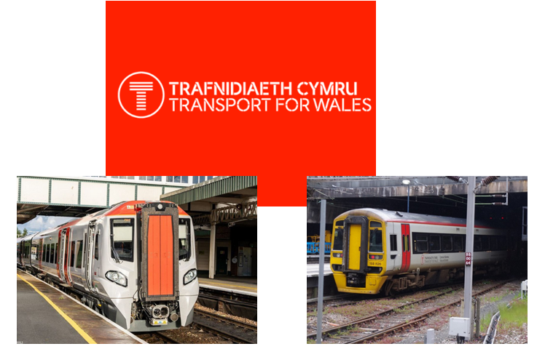

Cllr Ian Hodge
Cllr Norma Davies
Cllr Vivienne Blondek
Cllr Helen Roberts
Cllr Trevor Roberts
Robert Robinson MBE

Dated 15th February 2024

www.northwalesassociation.org.uk
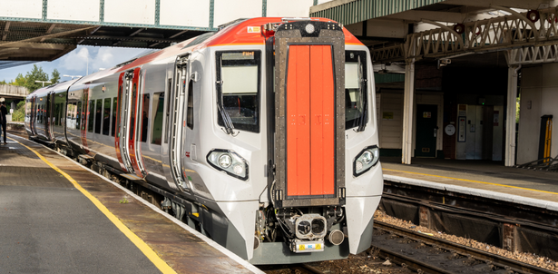
CONTENTS
- Introduction

- Survey method

- Survey no 1 – Flint – Birmingham International - Flint

- Survey no 2 – Shrewsbury – Chester – Birmingham - Shrewsbury

- Survey no 3 – Llandudno Junction – Holyhead – Chester –
Llandudno Junction

- Observation notes taken during surveys

- Customer care survey

- Summary

Appendix A – section 1 chart (Chester – Birmingham)

Appendix B – section 2 chart (Chester – Birmingham)

Appendix C – section 3 chart (Chester – Holyhead)

Appendix D – section 4 chart (Cambrian Line)

Appendix E – comparison charts

Appendix F – observations during the surveys

Appendix G - pictures

APPENDIX H – train designs and specifications

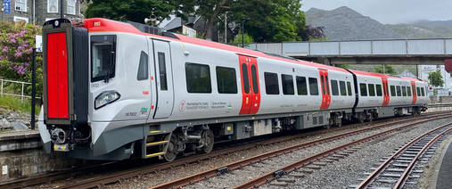

1. Introduction

This Rail Report is to added as an appendix to the report issued in October 2024 titled 8A.

The train loadings, passenger movements and customer service charts are included in this report for the date of the survey which was 15th February 2024.

A snapshot in time shows the reliability of trains on the day as an improvement on the recording in August/September 2023. The vast majority of trains on the Chester – Birmingham line ran on time or within 10 minutes of scheduled time. No cancellations recorded. There were more delays on the Chester – Holyhead line but nothing significant.

2. Survey method

The survey method was in person and each section of the survey was in the line with the last survey 8A. It was completed by two people as follows:

Section | Line | Surveyors
1 | Flint – Birmingham International – Flint | Cllr Ian Hodge  Cllr Norma Davies
2 | Chester – Birmingham International – Chester | Cllr Vivienne Blondek  Robert Robinson
3 | Llandudno Junction – Chester – Holyhead – Llandudno Junction | Cllr Helen Roberts
4 | Shrewsbury – Aberystwyth – Shrewsbury | Cllr Trevor Roberts and Robert Robinson

The results of the survey have been recorded and compared with previous survey results where this is possible.
3. Survey no 1 – completed by Cllr Ian Hodge & Cllr Norma Davies
Flint – Birmingham International – Flint

The survey results show the following situation from the trains surveyed:

- A two car unit between Chester and Birmingham is not adequate for any of the timetabled services. The survey results show overcrowding (even on 4 car units in places) on all trains at some point on their journey.
- Overcrowding is causing stress on trains due to{
- People not being able to get to toilets.
- The refreshment trolley not being able to get down the train.
- Luggage is an issue, not enough space in racks and the overhead storage is not deep enough to take a reasonable size of luggage.

The full results can be found:

- At appendix A for train journey details and passengers numbers.
- In section 7 of this report for customer service assessments
- At appendix F for list of observations recorded during the survey

4. Survey no 2 – completed by Cllr Vivienne Blondek & Robert Robinson
Shrewsbury – Chester – Birmingham International - Shrewsbury

The survey results show the following situation from the trains surveyed:

- A two car unit between Chester and Birmingham is not adequate for any of the timetabled services. The survey results show overcrowding (even on 4 car units in places) on all trains at some point on their journey.
- Overcrowding is causing stress on trains due to{
- People not being able to get to toilets.
- The refreshment trolley not being able to get down the train.
- There were some British Transport Police on board who expressed concern about the level of overcrowding on trains.
- Luggage is an issue, not enough space in racks and the overhead storage is not deep enough to take a reasonable size of luggage.

The full results can be found:

- At appendix B for train journey details and passengers numbers.
- In section 7 of this report for customer service assessments
- At appendix F for list of observations recorded during the survey

5. Survey no 3

The survey results show the following situation from the trains surveyed:

- A two car unit between Chester and Birmingham is not adequate for any of the timetabled services. The survey results show overcrowding (even on 4 car units in places) on all trains at some point on their journey.
- Overcrowding is causing stress on trains due to{
- People not being able to get to toilets.
- The refreshment trolley not being able to get down the train.
- Luggage is an issue, not enough space in racks and the overhead storage is not deep enough to take a reasonable size of luggage.

The full results can be found:

- At appendix C for train journey details and passengers numbers.
- In section 7 of this report for customer service assessments
- At appendix F for list of observations recorded during the survey

6. Notes taken during surveys

There were notes taken as observations on each train and these are set out at appendix G. Below is the list of the common ones recorded:

- Overcrowding issues at some point on all trains.

7. Customer care
The customer care survey has been compared with the previous surveys.
 | CUSTOMER CARE
 | REASON FOR TRAVEL
 | BUSINESS |  | 16%
 | HEALTH |  | 8%
 | PLEASURE |  | 68%
 | EDUCATION |  | 8%
 | FREQUENCY OF TRAVEL
 | DAILY |  | 0%
 | WEEKLY |  | 24%
 | MONTHLY |  | 16%
 | NOW AND AGAIN |  | 60%
 |  |  | OVERALL SCORES COMPARISON 2013-2024
Q | HEADING |  | ..2013 | ..2015 | ..2023.. | ..2024..
1 | Are your trains dependable |  | ..4.00 | 3.90 | 3.45 | 3.64
2 | Are your trains on time |  | ..4.00 | 3.90 | 3.10 | 3.45
3 | Are your trains clean |  | 3.70 | 3.70 | 3.31 | 3.41
4 | Are your trains comfortable |  | 4.20 | 3.80 | 3.74 | 3.03
5 | Are your trains overcrowded |  | 3.80 | 3.50 | 2.70 | 2.74
6 | Are the toilets good |  | 3.00 | 3.10 | 2.96 | 3.27
7 | Is there enough lugguage space |  | 3.00 | 3.00 | 3.07 | 3.50
8 | Were the staff friendly & helpful |  | 4.25 | 4.30 | 4.55 | 4.27
9 | Pre journey information |  |  |  | 3.32 | 4.12
10 | Onboard information |  |  | 4.10 | 4.40 | 3.87
11 | Adequate car parking at station |  | 4.40 | 4.40 | 4.10 | 3.94
12 | Did your staiton have booking office/ticket machine |  |  |  | 3.30 | 4.03
13 | Was there easy access to the train |  |  |  | 4.40 | 4.22
 | Options Shrewsbury-Chester - 2 car unit direct |  |  |  | 40%
 | Options Shrewsbury-Chester - 4 car unit changing |  |  |  | 60%

ASSESSMENT

The customer service chart shows:
- Standard of customer care is good except for two areas.
- The areas of concern are overcrowding which has received a reduced rating year on year since 2013.
- A 4 car unit changing at Shrewsbury (Birmingham – Holyhead service) is preferred to a two car direct service.

8.Summary

From the survey the following was of note:

- Overcrowding
- Customer service
- Police on the train

Appendix A – Section 1 – Train and passenger information

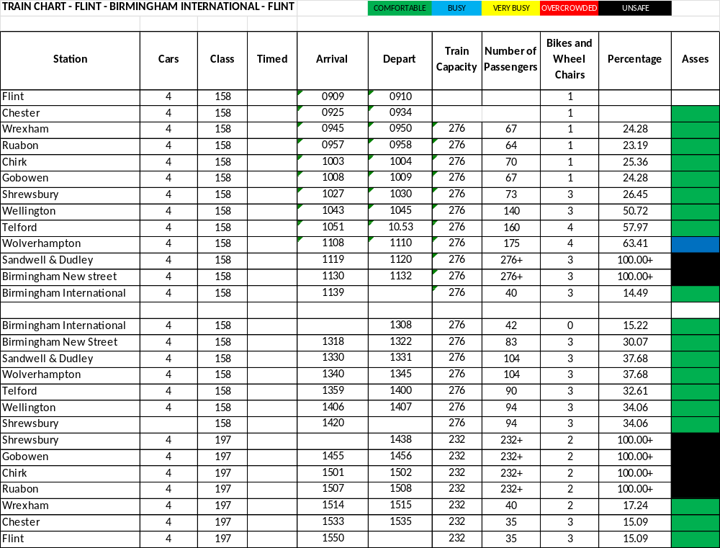

Appendix B – Section 2 – Train and passenger information

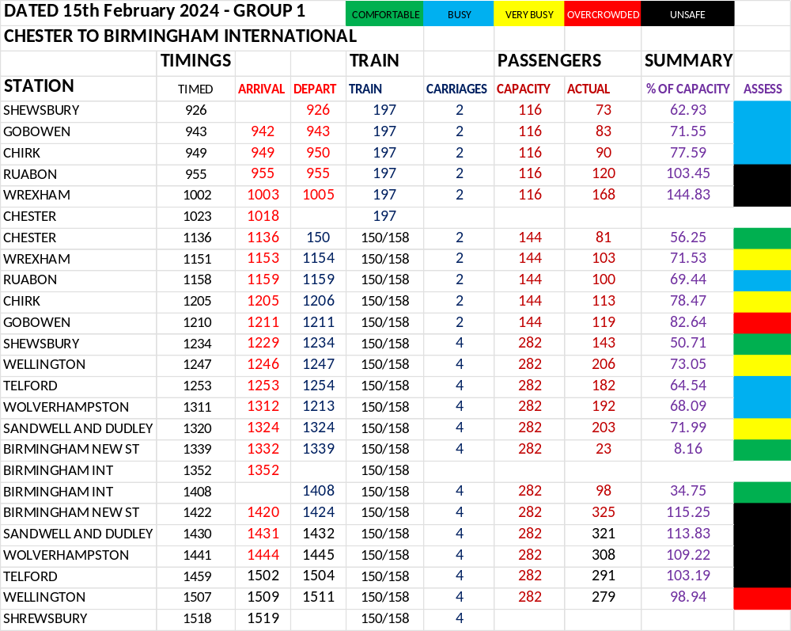

Appendix C – Section 3 – Train and passenger information
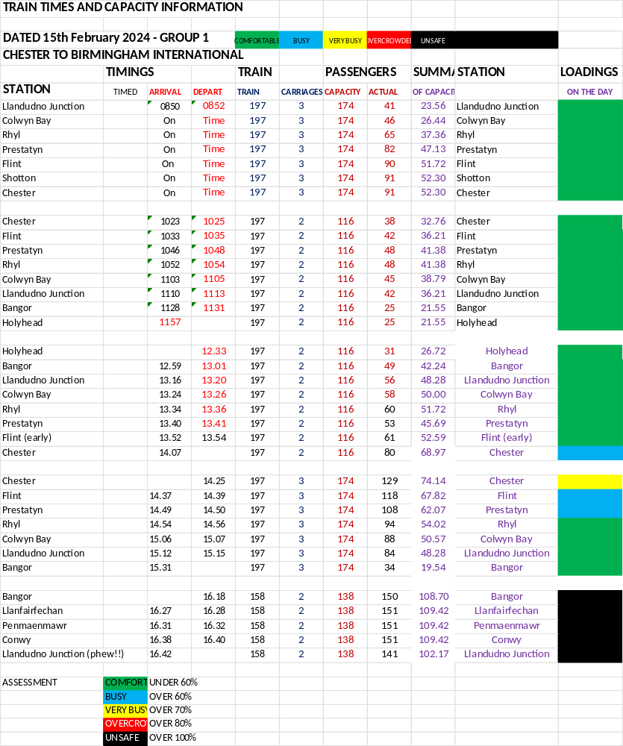

Appendix D – Section 4 – Train and passenger information

APPENDIX E – COMPARISON OF TRAIN NUMBERS & TRAINS

The charts below show what passenger loadings (taken on survey day) would be depending upon train provision.

FLINT – BIRMINGHAM INTERNATIONAL – FLIT
(trains mid-morning on 15th February 2024)

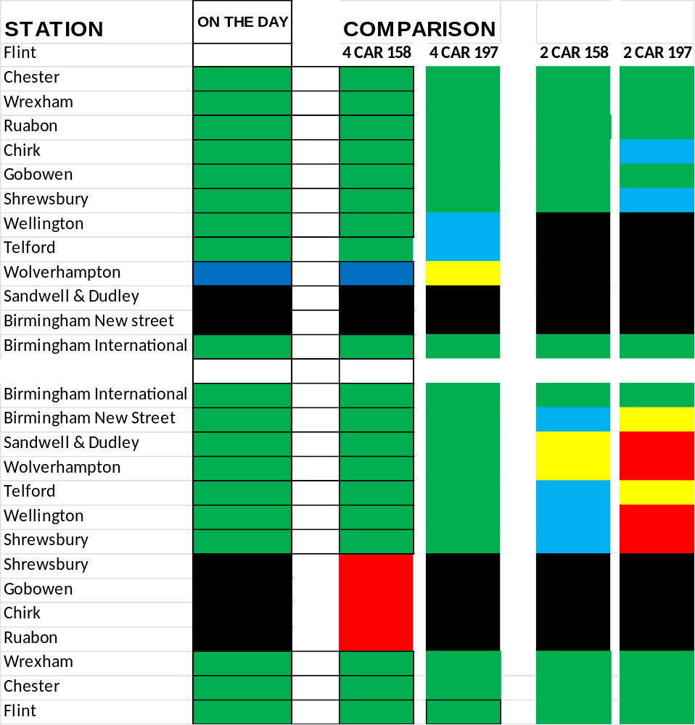

From the above it is clear that a 2 carriage train is inadequate at almost all times. This is particularly the case when you consider:
- Even on these fairly quiet trains only two carriages would have caused unsafe overcrowding in some areas of its journey.

SHREWSBURY – CHESTER – BIRMINGHAM INTERNATIONAL – SHREWSBURY
(trains middle of the day on 15th February 2024)

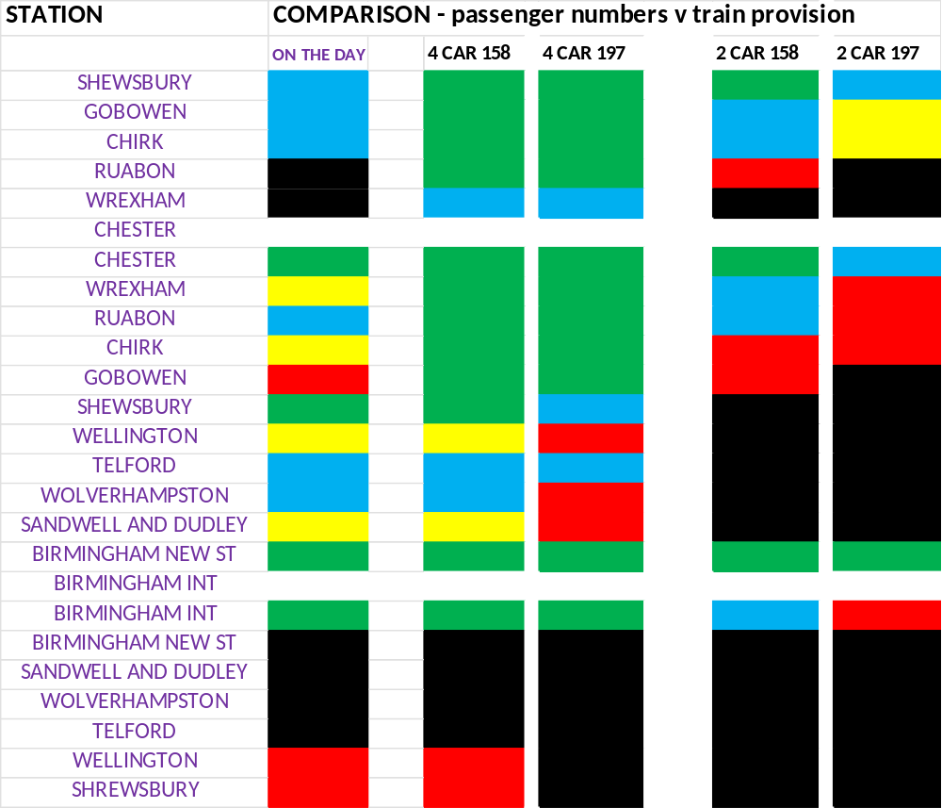

From the above it is clear that a 2 carriage train is inadequate at almost all times. This is particularly the case when you consider:
i)The new 197 class has less seating for passengers meaning that more will be standing for longer than the guideline 20 minutes.
ii) Difficulty of passengers getting to toilets and difficulty of the trolley service getting down the train due to overcrowding.

LLANDUDNO JUNCTION – CHESTER – HOLYHEAD – LLANDUDNO JUNCTION
(trains early part of the day on 15th February 2024)
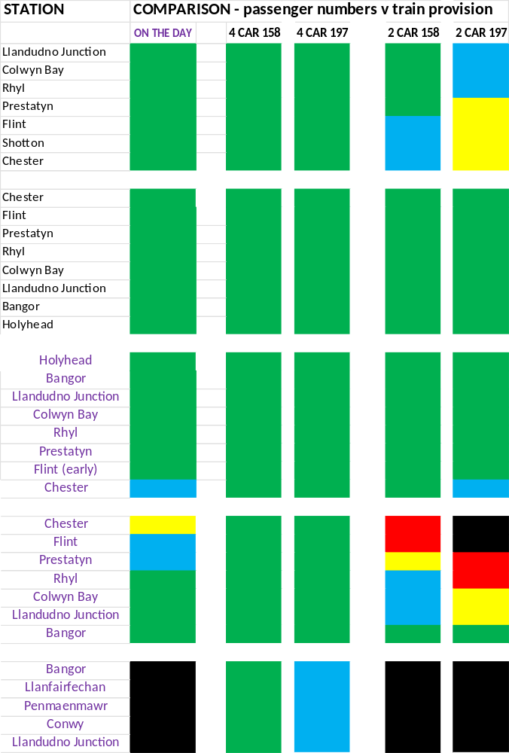

APPENDIX F
OBSERVATIONS DURING THE SURVEY – section 2

The following were the observations from the surveys:

- There were no working information screens on a new 197 class train from Shrewsbury to Chester at 09.26.
- Guards on all trains very friendly and helpful.
- There was a trolley service but on no train did they go down the train (too crowded and with luggage blocking route).
- A lot of standing passengers on all trains.
- As previous services ladies with very young children in prams or pushchairs forced to sit on floor due to lack of space.
- No enough luggage space on any train.
- British Transport Police on one train said ‘we need more carriages on these trains’. When asked if they considered it unsafe the response was ‘possibly’.
- Access to the toilet impeded by overcrowding at times.
- One train (class 150) had smelly toilets, the other trains were good.
- The class 150 train from Chester to Birmingham International and back to Shrewsbury was over warm with no air conditioning.
- Wifi on the class 150 train was not working.
- The number of passengers on the train with a 4 car unit Shrewsbury to Birmingham to Shrewsbury coped, a two car unit would not have taken the passengers on board.
- All passengers changed from train to train with the train from Birmingham turned around and went back so passengers had to change to a Holyhead and Aberystwyth train.
- One of our surveyors changed from a train in platform 4 (arrived at 15.18 to catch the Holyhead train at 15.32 (running a little late) on platform 3. Due to queues at the ticket barriers and time getting off of train she missed this connection causing an hours delay to her journey.
- Passengers on the train were generally police but were in some cases distressed due to lack of space and inability to get to the toilets.

APPENDIX G
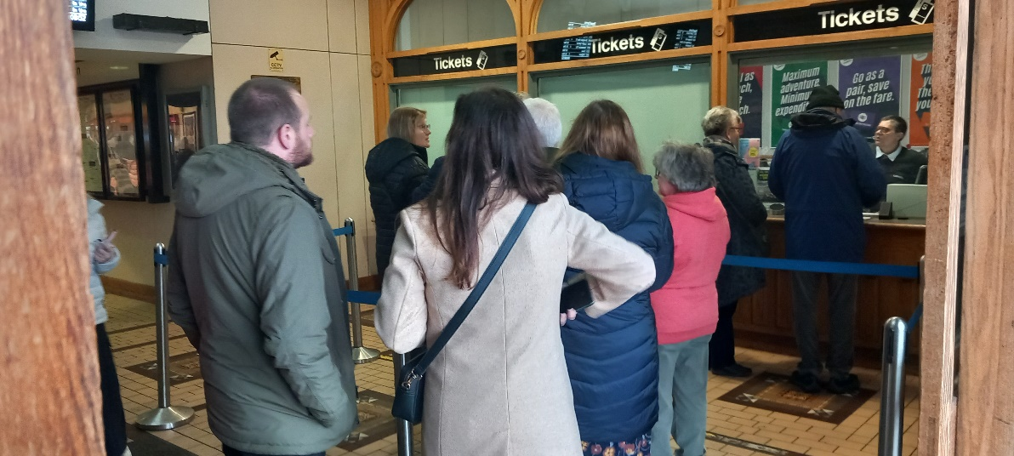
SHREWSBURY BOOKING OFFICE AROUND A LUNCHTIME – ONLY ONE TERMINAL OPEN

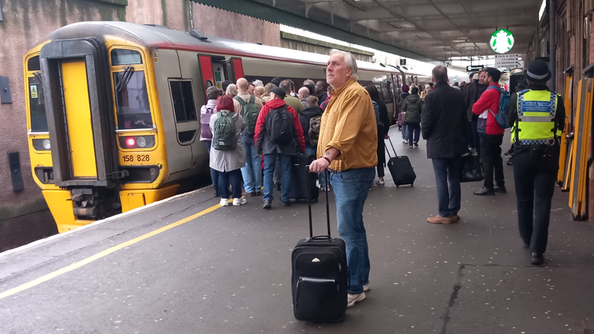
TRAIN FROM HOLYHEAD IN PLATFORM 7 AT SHREWSBURY, ANOTHER TWO UNITS ARE ABOUT OT ARRIVE TO CONNECT ONTO THE BACK OF THIS BIRMINGHAM BOUND TRAIN. PEOPLE ON PLATFORM ALL TRYING TO GET ON JUST THE FRONT TWO CARRIAGES. NO STATION STAFF ON THE PLATFORM TO INFORM AND ARRANGE PASSENGERS SO THAT THE CARRIAGES ABOUT TO ARRIVE CAN SPREAD THE LOAD.

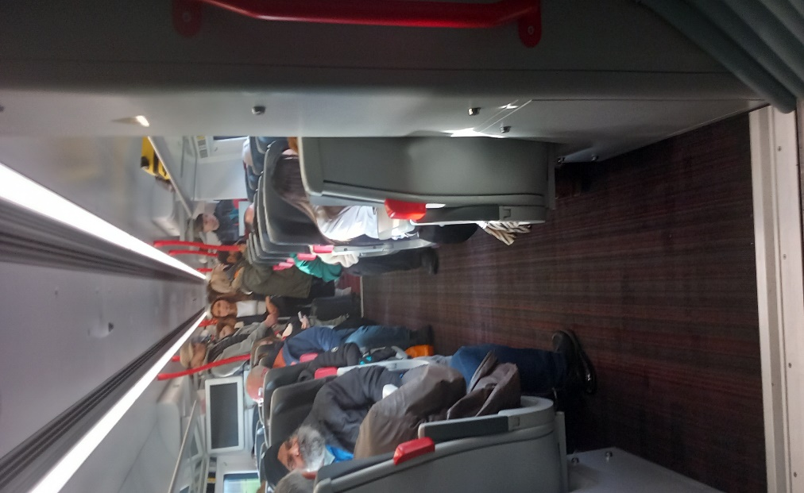
PICTURE DOWN THE TRAIN FROM SHREWSBURY TO CHESTER (BEFORE ARRIVING AT WREXHAM WHEN A LOT MORE PEOPLE GOT ON) TIMED AROUND 11am. THESE PEOPLE HAD TO STAND FROM SHEWSBURY TO CHESTER.
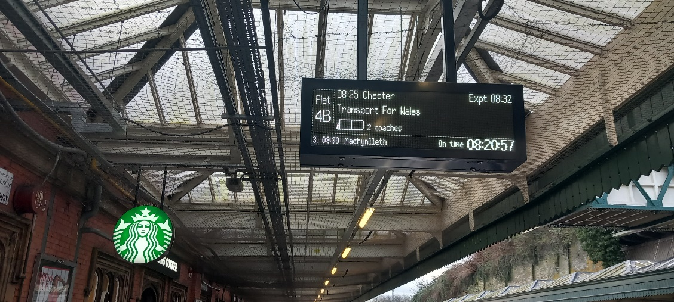
PEAK TIME (8.32am) – ONLY TWO CARRIAGES, NOT ADEQUATE.

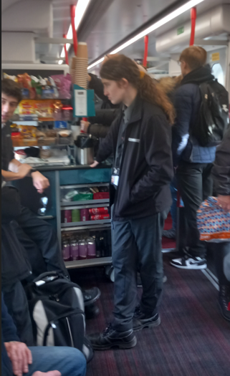
COMMON SIGHT ON TFW TRAINS. – TROLLY SERVICE BUT UNABLE TO GET DOWN THE TRAIN DUE TO OVERCROWDING.

APPENDIX H
TRAIN DESIGNS OF TFW FLEET
